**A project by : Mahek Rajesh Ahuja**

CONTENT

|  |  |  |
| --- | --- | --- |
| **Serial No:** | Topic | Page No: |
| **1** | INTRODUCTION  1.1 Problem Overview  1.2 Objective  1.3 System Requirements | 1 |
| 2 | PROBLEM ANALYSIS  2.1 Methodology  2.2 Process Flow (DFD) | 4 |
| 3 | DESIGN PHASE  3.1 Modularization Details  3.2 System Design Model  3.3 Program components and interface  3.4 Database table design  3.5 Flowchart of Website | 6 |
| 4 | CODING | 14 |
| 5 | TECHNICAL FESASIBILITY  5.1 Non-Functional Requirements  5.2 Accuracy  5.3 Usability  5.4 Accessibility  5.5 Performance  5.6 Reliability  5.7 Security | 32 |
| 6 | SYSTEM TESTING  6.1 Unit Testing  6.2 Integration Testing  6.3 Reports | 34 |
| 7 | OUTPUT SCREENSHOTS | 38 |
| 8 | LIMITATIONS | 47 |
| 9 | CONCLUSION | 48 |
| 10 | SCOPE AND ENHANCEMENT | 49 |
| 11 | APPENDIX | 51 |
| 12 | BIBILOGRAPHY | 54 |

**CHAPTER 1**

**INRODUCTION**

In today’s digital era, traditional bookstores face challenges like limited stock, geographical constraints, and long waiting times. Book Hive is an innovative e-commerce platform that simplifies book shopping by offering a structured and user-friendly online experience.

Users can effortlessly browse various genres, add books to their cart or wishlist, and track orders with real-time status updates, including stages like "Order Placed," "Packed," "Out for Delivery," and "Delivered."

A unique feature of Book Hive is its book donation system, enabling users to donate books and promote literacy while reducing waste. This initiative fosters a culture of knowledge-sharing and enhances book accessibility for a broader audience.

Developed with PHP, MySQL, HTML, CSS, and JavaScript, Book Hive ensures secure transactions, efficient database management, and robust user authentication. The platform prioritizes data integrity and payment security, ensuring a safe and reliable experience for customers.

By integrating modern web technologies, Book Hive revolutionizes book shopping and sets the foundation for future enhancements, such as AI-based book recommendations, multiple payment options, and subscription-based memberships. The platform aims to bridge the gap between readers and books, making literature more accessible, convenient, and impactful in the evolving digital landscape.

**1.3 System Requirements**

The section lists the minimum hardware and software requirements needed to run the system efficiently

|  |  |
| --- | --- |
| **HARDWARE**  **REQUIREMENTS** | **SOFTWARE**  **REQUIREMENTS** |
| * Intel Xeon E5-2680 v4 | * Front End: HTML, CSS, JS |
| * 8GB RAM ,160 GB Hard Disk | * Back End: PHP Using XAMPP |
| * Windows 10/11 | * Database: MYSQL |

**CHAPTER 2**

**PROBLEM ANALYSIS**

**2.1 Methodology**

To develop the system efficiently, we follow the Waterfall Model, which ensures a step-by-step development process.

1. Requirement Analysis – Understanding user needs and defining system features such as book listing, donation management, and payment processing.
2. System Design – Planning database structures, user interface layouts, and backend functionalities.
3. Implementation – Developing the website using HTML, CSS, JavaScript for the frontend and PHP, MySQL for the backend.
4. Testing – Identifying and fixing errors to ensure a smooth user experience.
5. Deployment & Maintenance – Launching the website and making regular updates for better performance.

This methodology ensures that the system is developed in an organized and effective manner.

**2.2 Process Flow (DFD)**

**2.2.1 Context level DFD for Online Book Store Website**

**2.2.2 1st Level DFD for users**

Fig-2.2.2

Fig-2.2.1

**CHAPTER 3**

**DESIGN PHASE**

**3.1 Modularization**

**User Management:** This module handles user-related functionalities, including registration, authentication, and role-based access control. It ensures that users can log in securely using encrypted passwords and access different system features based on their roles (Admin/User).

**Register & Login Page:** This module allows users to create an account and log into the system. The registration form collects details such as name, email, and password. The login system verifies credentials, and users are authenticated using a hashed password for security. The system also includes a password reset feature.

**User Category Page:** This module displays books based on user preferences and categories. Users can browse books under different categories such as Fiction, Non-Fiction, Science, History, etc. It allows personalized recommendations and helps users navigate through books efficiently.

**Book Management:** This module manages book records, including adding new books, updating details, and tracking their availability. It ensures books can be categorized based on genre, author, and category, and users can view book details easily.

**Admin Category Management:** This module helps in organizing books under different categories. Admins can create, edit, and delete categories, making it easier for users to browse books by category.

**Search & Filter:** This module provides users with an intuitive way to search and filter books. Users can search by title, author, genre, category, or availability status. The filtering options ensure they quickly find the books they need.

**Cart Page:** This module allows users to add books they intend to purchase to their cart. It fetches the user's selected books from the database and displays them in a structured format, showing details like book title, author, category, and price. Users can remove books or proceed to checkout to confirm their transaction.

**Reports & Analytics:** This module generates reports and insights into the system's activities. It tracks donation trends, user engagement, and system performance. Admins can use this information for better decision-making and system improvements.

**Admin Dashboard:** The Admin Dashboard allows administrators to manage users, books, categories, and transactions. It provides an easy-to-use interface for monitoring the system, resolving issues, and performing administrative actions like removing or updating book records.

**3.2 System Design Model**

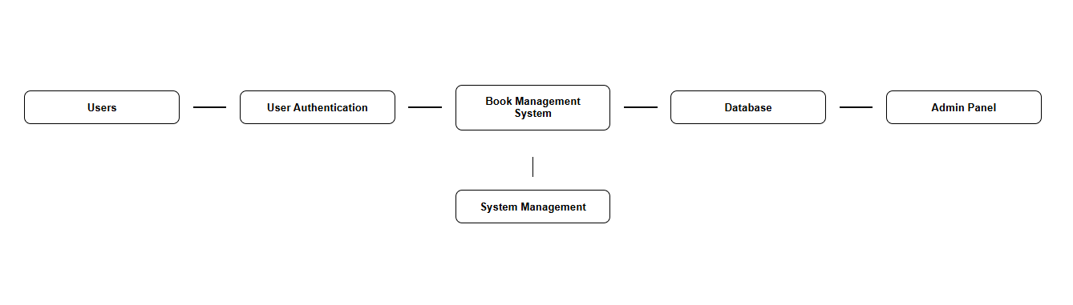

Fig-3.2.1

**3.2.2 E-R Diagram:**

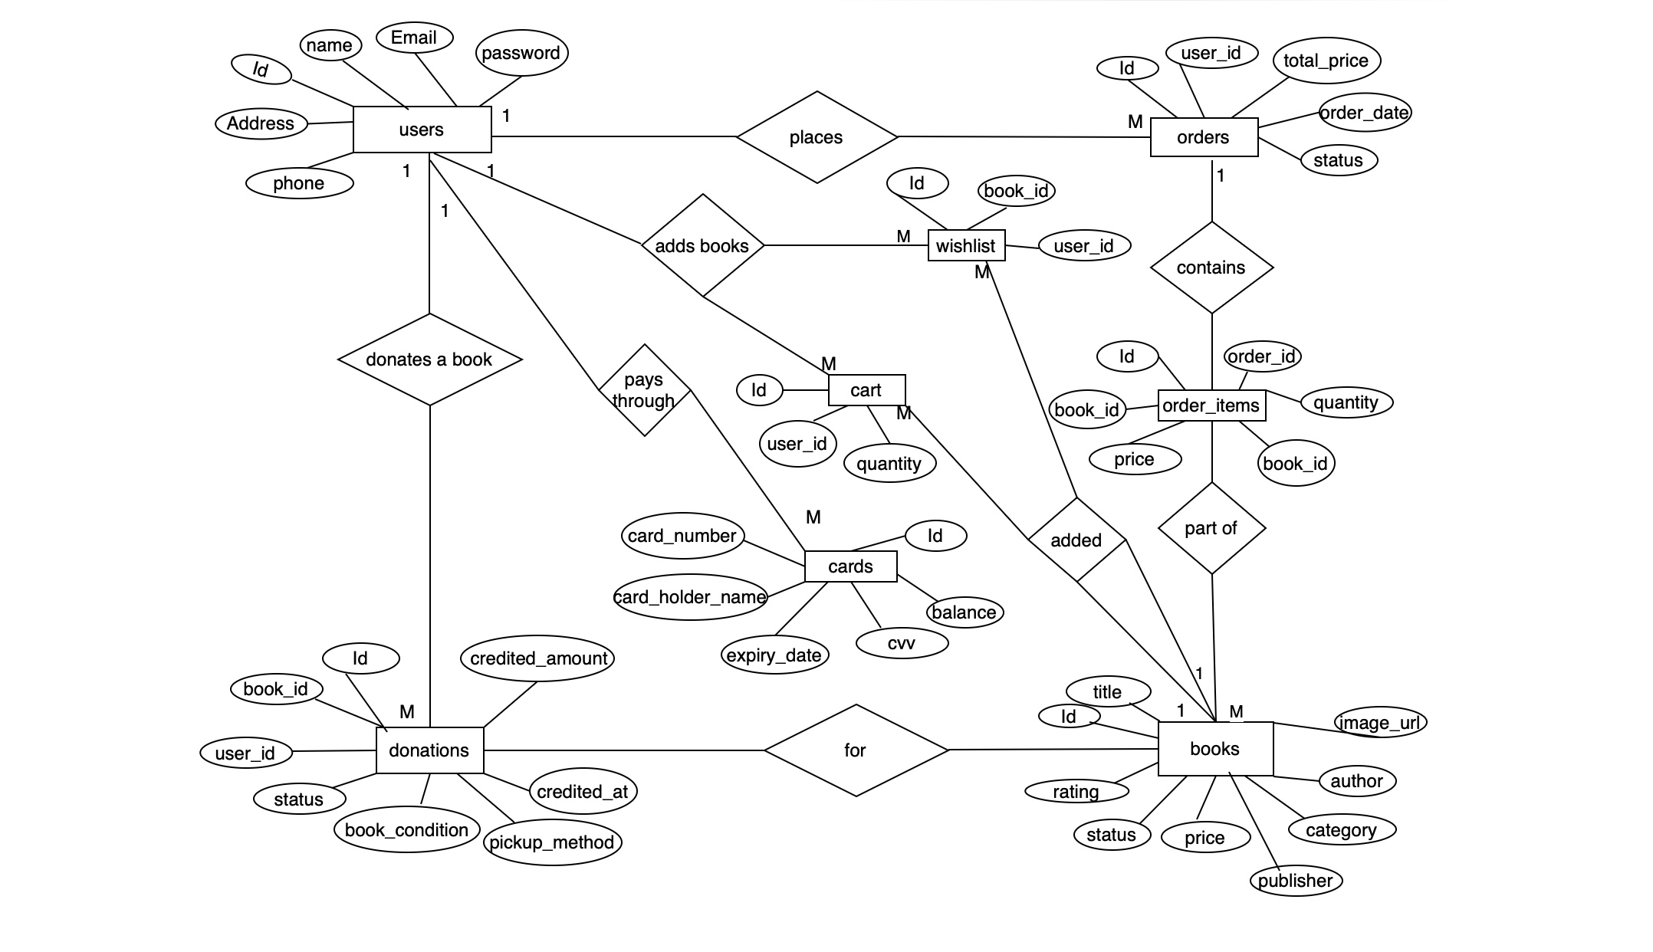

Fig-3.2.2

**3.2.3 Schema Diagram**

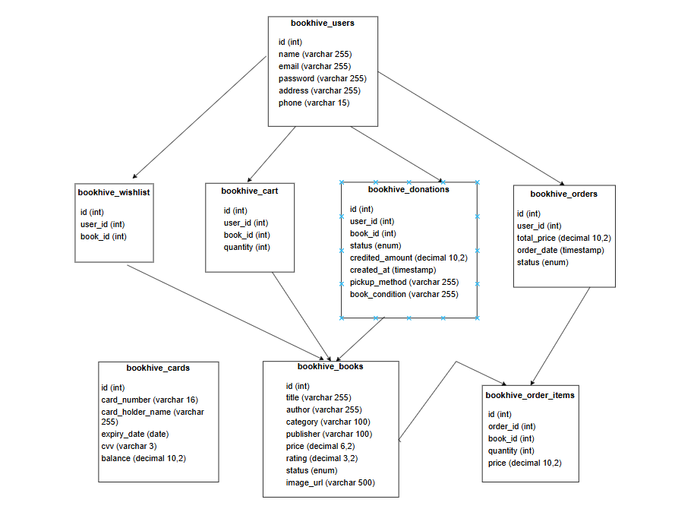

Fig-3.2.3

**3.3 Program components and interface**

Designing a book website involves serval program components and interface to provide users with a seamless experience. Here’s a breakdown of some essential components and interface

**3.3.1 User Interface (UI):**

The front-end design of the system should be user-friendly and responsive. The main pages include:

* Home Page: Displays featured books, search bar, and user options.
* Login/Register Page: Allows users to create accounts and log in.
* Book Listing Page: Shows available books with categories and filters.
* Book Details Page: Provides detailed information about a selected book with options to add to the wishlist or purchase.
* Cart & Checkout Page: Handles book purchases and order placement.
* Order Tracking Page: Allows users to track their book orders.
* Wishlist Page: Stores books that users want to purchase later.
* User Profile Page: Displays user information and order history.

**3.3.2 Backend Components:**

(a) Database (MySQL)

* Users Table: Stores user data (name, email, password, order history).
* Books Table: Stores book details (title, author, availability).
* Wishlist Table: Tracks books added to the wishlist.
* Orders Table: Manages purchases and payment records.
* Payments Table: Stores transaction details for purchases.

(b) Server (PHP)

* Authentication System: Handles user registration and login.
* Book Management: CRUD operations (Create, Read, Update, Delete) for books.
* Order Processing: Handles purchases.
* Wishlist Handling: Allows users to add/remove books from wishlist.
* Payment Gateway Integration: Manages online payments securely.

(c) API

* Used for communication between the frontend and backend.
* Endpoints for books, users, orders, wishlist, and payments.

**3.3.3 Interactive Features:**

* Search & Filters: Enables users to quickly find books.
* Wishlist: Allows users to save books for later purchase.
* Real-time Notifications: Alerts users about new arrivals and order status.

**3.3.4 Responsive Design:**

Ensures the website is accessible and functional across various devices such as smartphones, tablets and desktops

**3.3.5 Security Measures:**

Implementation of SSL certificates for secure data transfer, encryption protocols for sensitive information and secure authentication methods to protect user accounts and payment details

**3.3.6 Performance Optimization:**

Caching mechanism to improve loading speed, content delivery networks (CDNs) for faster content delivery and efficient database querying for seamless user experience

**3.4 Database Table Design**

**STRUCTURE:**

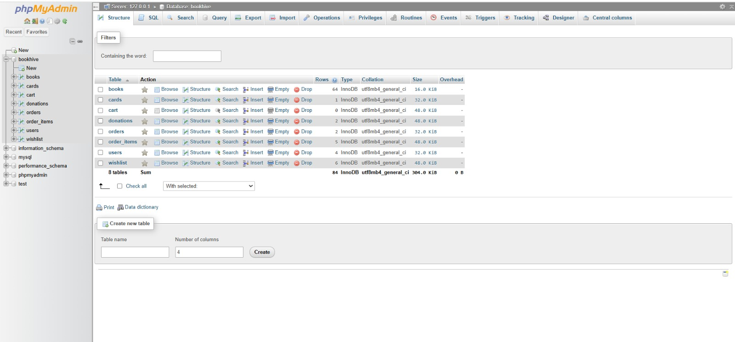

Fig-3.4.1

**USER TABLE:**

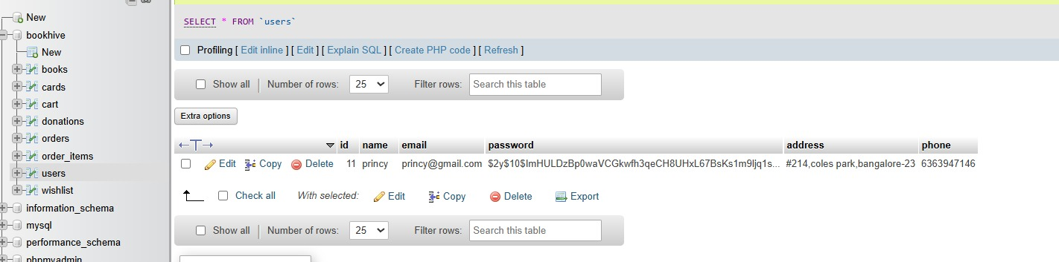

Fig-3.4.2

**3.5 Flowchart of Website:** 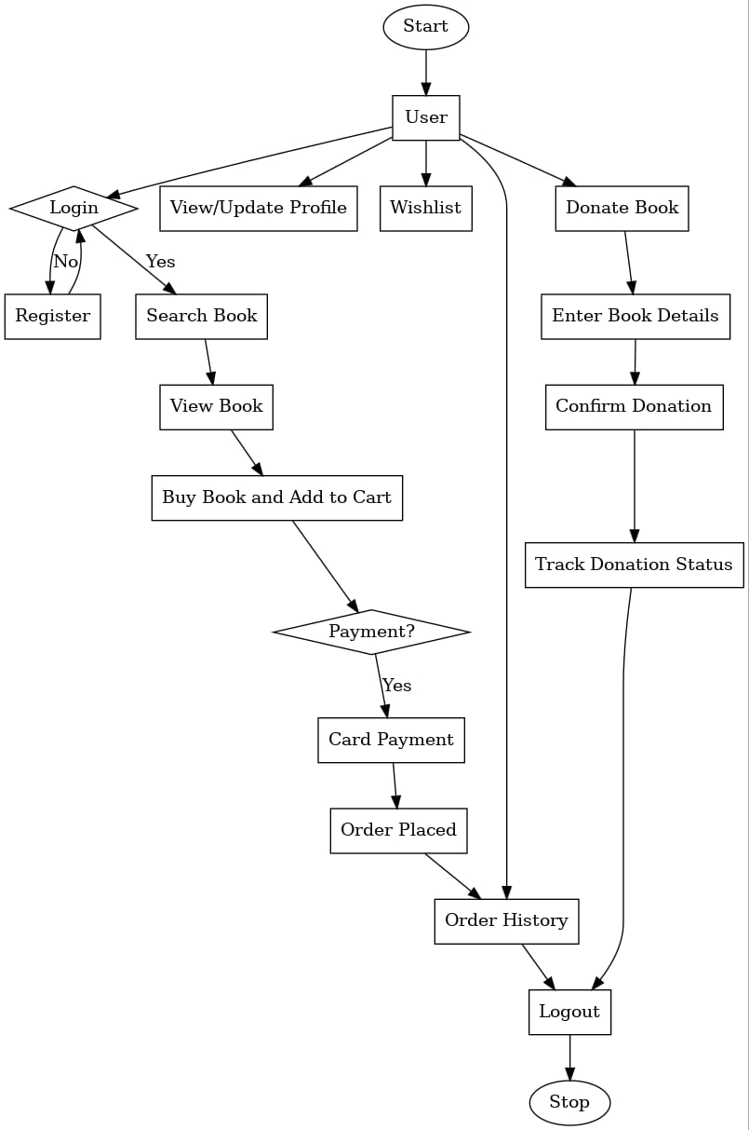

**Fig-3.5**

**CHAPTER 4**

**CODING**

**4.1 Login Page**

<!DOCTYPE html>

<html lang="en">

<head>

    <meta charset="UTF-8">

    <meta name="viewport" content="width=device-width, initial-scale=1.0">

    <title>Medilocker - Login</title>

    <style>

        body {

            margin: 0;

            font-family: Arial, sans-serif;

            overflow: hidden;

            display: flex;

            justify-content: center;

            align-items: center;

            height: 100vh;

            position: relative;

        }

        #bg-video {

            position: absolute;

            top: 0;

            left: 0;

            width: 100%;

            height: 100%;

            object-fit: cover;

            z-index: -1;

        }

        .login-container {

            display: block;

            position: absolute;

            top: 50%;

            left: 50%;

            transform: translate(-50%, -50%);

            background: rgba(255, 255, 255, 0.9);

            padding: 20px;

            border-radius: 10px;

            text-align: center;

            box-shadow: 0px 0px 10px rgba(0, 0, 0, 0.1);

            width: 90%;

            max-width: 400px;

        }

        .logo {

            width: 120px; /* Adjust size as needed */

            margin-bottom: 20px;

        }

        input {

            width: 100%;

            padding: 10px;

            margin: 10px 0;

            border: 1px solid #ccc;

            border-radius: 5px;

        }

        button {

            background: #28a745;

            color: #fff;

            border: none;

            padding: 10px;

            border-radius: 5px;

            cursor: pointer;

            width: 100%;

            font-size: 16px;

        }

        button:hover {

            background: #218838;

        }

        p {

            margin-top: 10px;

        }

        a {

            color: #007bff;

            text-decoration: none;

        }

        a:hover {

            text-decoration: underline;

        }

    </style>

</head>

<body>

    <!-- Background Video -->

    <video autoplay muted loop id="bg-video">

        <source src="videos/login.mp4" type="video/mp4">

    </video>

    <div class="login-container">

        <!-- Logo -->

        <img src="images/medilockerlogo.webp" alt="Logo" class="logo">

        <h2>Login</h2>

        <form id="loginForm">

            <input type="text" name="full_name" id="full_name" placeholder="Full Name" required>

            <input type="password" name="password" id="password" placeholder="Password" required>

            <button type="submit">Login</button>

        </form>

        <p>Don't have an account? <a href="personal_detail.html">Create New Account</a></p>

    </div>

    <script>

        // Function to handle login

        document.getElementById("loginForm").addEventListener("submit", function(event) {

            event.preventDefault(); // Prevent form from submitting

            let fullName = document.getElementById("full_name").value;

            let password = document.getElementById("password").value;

            // Check if both fields are filled

            if (fullName && password) {

                alert("Logged in successfully!");

                window.location.href = "home.html"; // Redirect to the home page

            } else {

                alert("Wrong input check");

            }

        });

    </script>

</body>

</html>

**4.2Login.php**

<!DOCTYPE html>

<html lang="en">

<head>

    <meta charset="UTF-8">

    <meta name="viewport" content="width=device-width, initial-scale=1.0">

    <title>Medilocker - Login</title>

    <style>

        body {

            margin: 0;

            font-family: Arial, sans-serif;

            overflow: hidden;

            display: flex;

            justify-content: center;

            align-items: center;

            height: 100vh;

            position: relative;

        }

        #bg-video {

            position: absolute;

            top: 0;

            left: 0;

            width: 100%;

            height: 100%;

            object-fit: cover;

            z-index: -1;

        }

        .login-container {

            display: block;

            position: absolute;

            top: 50%;

            left: 50%;

            transform: translate(-50%, -50%);

            background: rgba(255, 255, 255, 0.9);

            padding: 20px;

            border-radius: 10px;

            text-align: center;

            box-shadow: 0px 0px 10px rgba(0, 0, 0, 0.1);

            width: 90%;

            max-width: 400px;

        }

        .logo {

            width: 120px; /* Adjust size as needed */

            margin-bottom: 20px;

        }

        input {

            width: 100%;

            padding: 10px;

            margin: 10px 0;

            border: 1px solid #ccc;

            border-radius: 5px;

        }

        button {

            background: #28a745;

            color: #fff;

            border: none;

            padding: 10px;

            border-radius: 5px;

            cursor: pointer;

            width: 100%;

            font-size: 16px;

        }

        button:hover {

            background: #218838;

        }

        p {

            margin-top: 10px;

        }

        a {

            color: #007bff;

            text-decoration: none;

        }

        a:hover {

            text-decoration: underline;

        }

    </style>

</head>

<body>

    <!-- Background Video -->

    <video autoplay muted loop id="bg-video">

        <source src="videos/login.mp4" type="video/mp4">

    </video>

    <div class="login-container">

        <!-- Logo -->

        <img src="images/medilockerlogo.webp" alt="Logo" class="logo">

        <h2>Login</h2>

        <form id="loginForm">

            <input type="text" name="full_name" id="full_name" placeholder="Full Name" required>

            <input type="password" name="password" id="password" placeholder="Password" required>

            <button type="submit">Login</button>

        </form>

        <p>Don't have an account? <a href="personal_detail.html">Create New Account</a></p>

    </div>

    <script>

        // Function to handle login

        document.getElementById("loginForm").addEventListener("submit", function(event) {

            event.preventDefault(); // Prevent form from submitting

            let fullName = document.getElementById("full_name").value;

            let password = document.getElementById("password").value;

            // Check if both fields are filled

            if (fullName && password) {

                alert("Logged in successfully!");

                window.location.href = "home.html"; // Redirect to the home page

            } else {

                alert("Wrong input check");

            }

        });

    </script>

</body>

</html>

**4.3Doctor’s Appointment.html**

<!DOCTYPE html>

<html lang="en">

<head>

    <meta charset="UTF-8">

    <meta name="viewport" content="width=device-width, initial-scale=1.0">

    <title>Top Doctors in Bangalore and India</title>

    <style>

        body {

            font-family: 'Arial', sans-serif;

            margin: 0;

            padding: 0;

            background-color: #f7f7f7;

            background-image: url('images/hospitals.png'); /* Background image */

            background-size: cover; /* Ensures the background image covers the whole page */

            background-position: center; /* Centers the image */

            background-attachment: fixed; /* Keeps the background fixed during scrolling */

        }

        .container {

            max-width: 900px;

            margin: 40px auto;

            background-color: white;

            padding: 20px;

            border-radius: 10px;

            box-shadow: 0 0 15px rgba(0, 0, 0, 0.1);

        }

        h1 {

            text-align: center;

            color: #333;

            font-size: 2.5rem;

            margin-bottom: 20px;

        }

        h2 {

            color: #444;

            font-size: 1.8rem;

            margin-top: 30px;

            margin-bottom: 10px;

        }

        h3 {

            color: #555;

            font-size: 1.4rem;

            margin-top: 20px;

            margin-bottom: 10px;

        }

        p {

            font-size: 1.1rem;

            color: #666;

            line-height: 1.8;

            margin-bottom: 20px;

        }

        ul {

            padding-left: 20px;

            color: #555;

        }

        ul li {

            margin-bottom: 10px;

            list-style-type: disc;

        }

        .divider {

            margin: 30px 0;

            border-bottom: 2px solid #ddd;

        }

        .cta {

            text-align: center;

            background-color: #2196f3;

            color: white;

            padding: 15px;

            border-radius: 5px;

            cursor: pointer;

            font-size: 1.1rem;

            transition: background-color 0.3s;

        }

        .cta:hover {

            background-color: #1976d2;

        }

    </style>

</head>

<body>

    <div class="container">

        <h1>Top Doctors in Bangalore and India</h1>

        <div class="section">

            <h2>Top 10 Doctors in Bangalore</h2>

            <p>Bangalore is home to a number of world-renowned doctors in various specialties. Below are the top 10 doctors in Bangalore, known for their exceptional skills and achievements:</p>

            <ul>

                <li><strong>Dr. Devi Shetty</strong> - Specialties: Cardiology, Cardiac Surgery<br>Achievements: Founder of Narayana Health, pioneered affordable cardiac surgery in India. Works at Narayana Health, Bangalore.</li>

                <li><strong>Dr. Shanthala Thuppanna</strong> - Specialties: Dermatology, Laser Surgery<br>Achievements: Expertise in dermatologic surgery and hair restoration, recognized for her excellence in skincare. Works at Sakra Premium Clinic, Bangalore.</li>

                <li><strong>Dr. Prathima Reddy</strong> - Specialties: Obstetrics, Gynecology<br>Achievements: Former President of FOGSI, recognized for her contributions to women’s health. Works at Fortis La Femme, Bangalore.</li>

                <li><strong>Dr. Rajeshwari R</strong> - Specialties: Pediatrics, Neonatology<br>Achievements: Known for her expertise in neonatal care and pediatrics, with over 20 years of experience. Works at Cloudnine Hospital, Bangalore.</li>

                <li><strong>Dr. Asha Kewalramani</strong> - Specialties: Ophthalmology<br>Achievements: Specializes in cataract surgery, glaucoma management, and laser treatments. Works at Rajan Eye Care Hospital, Bangalore.</li>

                <li><strong>Dr. Sudarshan Ballal</strong> - Specialties: Nephrology, Kidney Transplantation<br>Achievements: Renowned kidney transplant specialist and former President of the Indian Society of Nephrology. Works at Manipal Hospital, Bangalore.</li>

                <li><strong>Dr. Anil K. Gupta</strong> - Specialties: Orthopedics, Spine Surgery<br>Achievements: Leading spine surgeon with over 25 years of experience, specializes in minimal invasive spine surgeries. Works at Sakra Premium Clinic, Bangalore.</li>

                <li><strong>Dr. Ganesh G</strong> - Specialties: Gastroenterology<br>Achievements: Specializes in gastrointestinal disorders, recognized for his innovative approaches in treatment. Works at Care Clinic, Bangalore.</li>

                <li><strong>Dr. Sangeeta Gomes</strong> - Specialties: Breast Cancer, Oncology<br>Achievements: Pioneer in breast cancer treatment, well-known for her expertise in medical oncology. Works at Vikram Hospital, Bangalore.</li>

                <li><strong>Dr. Vivek Srinivasan</strong> - Specialties: Neurosurgery<br>Achievements: Renowned for his work in brain and spine surgery, specializing in complex neurological procedures. Works at St. John's Medical College Hospital, Bangalore.</li>

            </ul>

        </div>

        <div class="divider"></div>

        <div class="section">

            <h2>Top 10 Doctors in India</h2>

            <p>India boasts a wide range of experts in various medical fields, many of whom are internationally acclaimed for their skills and achievements. Below is a list of the top 10 doctors in India:</p>

            <ul>

                <li><strong>Dr. Naresh Trehan</strong> (New Delhi) - Specialties: Cardiology, Cardiac Surgery<br>Achievements: Renowned heart surgeon and founder of Medanta – The Medicity, one of India's top hospitals.</li>

                <li><strong>Dr. Randeep Guleria</strong> (New Delhi) - Specialties: Pulmonology<br>Achievements: Director of AIIMS, recognized for his contributions to respiratory medicine and COVID-19 research.</li>

                <li><strong>Dr. V. Shantharam</strong> (Chennai) - Specialties: Orthopedics<br>Achievements: Leading orthopedic surgeon, specialized in joint replacement surgery and sports medicine.</li>

                <li><strong>Dr. Arvind Kumar</strong> (New Delhi) - Specialties: Thoracic Surgery, Lung Transplants<br>Achievements: Expert in lung cancer and transplant surgery, performed several successful lung transplants in India.</li>

                <li><strong>Dr. Sushil Kumar</strong> (Mumbai) - Specialties: Gastroenterology, Hepatology<br>Achievements: Internationally acclaimed for his work in liver transplantation and hepatitis research.</li>

                <li><strong>Dr. Ramakant Deshpande</strong> (Mumbai) - Specialties: Oncology, Cancer Treatment<br>Achievements: Recognized for his contributions to cancer research and for pioneering advanced cancer treatments in India.</li>

                <li><strong>Dr. A.P. J. Abdul Kalam</strong> (Former President, India) - Specialties: Cardiovascular Medicine<br>Achievements: Known for his innovative contributions to medical research, especially in cardiovascular medicine, and for his leadership in India's healthcare reforms.</li>

                <li><strong>Dr. Ashok Seth</strong> (New Delhi) - Specialties: Cardiology<br>Achievements: One of India's foremost cardiologists, recognized for his innovative techniques in angioplasty and heart surgeries.</li>

                <li><strong>Dr. Bharat Agrawal</strong> (Kolkata) - Specialties: Urology<br>Achievements: Renowned for his expertise in robotic urological surgeries and for developing new techniques in kidney surgery.</li>

                <li><strong>Dr. Shekhar Seshadri</strong> (Bangalore) - Specialties: Psychiatry<br>Achievements: A well-known psychiatrist and mental health expert, contributing to mental health research and awareness in India.</li>

            </ul>

        </div>

        <div class="divider"></div>

        <div class="section">

            <h2>Conclusion</h2>

            <p>India is home to a number of highly skilled and renowned doctors who are experts in their respective fields. Whether you are looking for expertise in heart surgery, neurosurgery, oncology, or any other specialized treatment, these doctors are leading the way in providing top-notch medical care. Many of these doctors have pioneered medical advancements and are internationally recognized for their contributions to healthcare.</p>

        </div>

        <div class="cta" onclick="alert('Thank you for reading!')">Share your thoughts in the comments below!</div>

    </div>

</body>

</html>

**4.4 Doctor’s submit.php**

<?php

// Database connection parameters

$host = 'localhost'; // or your host

$db = 'medilocker'; // Your database name

$user = 'root'; // Your database username

$pass = ''; // Your database password

// Create a new PDO instance

try {

    $pdo = new PDO("mysql:host=$host;dbname=$db", $user, $pass);

    $pdo->setAttribute(PDO::ATTR_ERRMODE, PDO::ERRMODE_EXCEPTION);

} catch (PDOException $e) {

    die("Could not connect to the database $db: " . $e->getMessage());

}

// Check if form is submitted

if ($_SERVER['REQUEST_METHOD'] == 'POST') {

    // Get form data

    $dr_name = $_POST['dr_name'];

    $specialization = $_POST['specialization'];

    $health_problem = $_POST['health_problem'];

    // Prepare SQL statement to insert data into the dr_appointment table

    $sql = "INSERT INTO dr_appointment (dr_name, specialization, health_problem)

            VALUES (:dr_name, :specialization, :health_problem)";

    // Prepare and execute the query

    try {

        $stmt = $pdo->prepare($sql);

        $stmt->bindParam(':dr_name', $dr_name);

        $stmt->bindParam(':specialization', $specialization);

        $stmt->bindParam(':health_problem', $health_problem);

        if ($stmt->execute()) {

            echo "<script>alert('Doctor details added successfully!'); window.location.href='home.html';</script>";

        } else {

            echo "<script>alert('Failed to add doctor details. Please try again.'); window.location.href='doctor_form.html';</script>";

        }

    } catch (PDOException $e) {

        echo "<script>alert('Error: " . $e->getMessage() . "'); window.location.href='doctor_form.html';</script>";

    }

}

?>

**4.5Video call.html**

<!DOCTYPE html>

<html lang="en">

<head>

    <meta charset="UTF-8">

    <meta name="viewport" content="width=device-width, initial-scale=1.0">

    <title>Video Call Appointment</title>

    <style>

        body {

            font-family: Arial, sans-serif;

            margin: 0;

            padding: 0;

            display: flex;

            justify-content: center;

            align-items: center;

            height: 100vh;

            background: rgba(0, 0, 0, 0.5);

            position: relative;

        }

        video {

            position: fixed;

            top: 0;

            left: 0;

            width: 100%;

            height: 100%;

            object-fit: cover;

            z-index: -1;

        }

        .container {

            display: flex;

            background-color: white;

            padding: 20px;

            border-radius: 10px;

            box-shadow: 0px 0px 15px rgba(0, 0, 0, 0.2);

        }

        .doctor-list {

            width: 40%;

            padding: 10px;

            border-right: 2px solid #ddd;

        }

        .doctor-item {

            padding: 10px;

            border-bottom: 1px solid #ddd;

            cursor: pointer;

        }

        .doctor-item:hover {

            background-color: #e9ecef;

        }

        .form-container {

            flex: 1;

            padding: 0 20px;

        }

        h2 {

            color: #28a745;

            text-align: center;

        }

        label {

            font-size: 16px;

            display: block;

            margin-top: 10px;

        }

        input {

            width: 100%;

            padding: 10px;

            margin-top: 5px;

            border-radius: 5px;

            border: 1px solid #ccc;

        }

        button {

            background-color: #007BFF;

            color: white;

            padding: 10px;

            border-radius: 5px;

            cursor: pointer;

            width: 100%;

            margin-top: 20px;

            border: none;

        }

        button:hover {

            background-color: #0056b3;

        }

        .message {

            display: none;

            text-align: center;

            background-color: #28a745;

            color: white;

            padding: 20px;

            border-radius: 5px;

            position: absolute;

            top: 20px;

            width: 100%;

        }

        .go-home-btn {

            background-color: #ff4081;

            color: white;

            padding: 10px;

            border-radius: 5px;

            cursor: pointer;

            width: 100%;

            margin-top: 10px;

            border: none;

        }

        .go-home-btn:hover {

            background-color: #e53935;

        }

    </style>

    <script>

        // Function to handle doctor selection

        function selectDoctor(name, specialization) {

            document.getElementById("dr_name").value = name;

            document.getElementById("specialisation").value = specialization;

        }

        // Function to handle the form submission via AJAX

        function submitAppointment(event) {

            event.preventDefault(); // Prevent form submission (page reload)

            var formData = new FormData(document.getElementById("appointmentForm"));

            // Create an AJAX request

            var xhr = new XMLHttpRequest();

            xhr.open("POST", "videocall.php", true);

            xhr.onload = function() {

                if (xhr.status === 200) {

                    // Show success message and populate appointment details

                    var doctorName = document.getElementById("dr_name").value;

                    var appointmentDate = document.getElementById("date").value;

                    document.getElementById("appointmentDoctor").textContent = doctorName;

                    document.getElementById("appointmentDateTime").textContent = appointmentDate;

                    document.getElementById("successMessage").style.display = "block";

                }

            };

            xhr.send(formData);

        }

        // Function to redirect after clicking OK or Go to Home

        function redirectToHome() {

            window.location.href = "home.html"; // Redirect to the home page

        }

    </script>

</head>

<body>

    <video autoplay loop muted>

        <source src="videos/videocall.mp4" type="video/mp4">

    </video>

    <div class="container">

        <div class="doctor-list">

            <h3>Available Doctors</h3>

            <div class="doctor-item" onclick="selectDoctor('Dr. Smith', 'Cardiologist')">Dr. Smith - Cardiologist</div>

            <div class="doctor-item" onclick="selectDoctor('Dr. Johnson', 'Dermatologist')">Dr. Johnson - Dermatologist</div>

            <div class="doctor-item" onclick="selectDoctor('Dr. Williams', 'Neurologist')">Dr. Williams - Neurologist</div>

            <div class="doctor-item" onclick="selectDoctor('Dr. Brown', 'Pediatrician')">Dr. Brown - Pediatrician</div>

        </div>

        <div class="form-container">

            <h2>Video Call Appointment Form</h2>

            <form id="appointmentForm" onsubmit="submitAppointment(event)">

                <label for="dr_name">Doctor Name:</label>

                <input type="text" id="dr_name" name="dr_name" required><br><br>

                <label for="specialisation">Specialisation:</label>

                <input type="text" id="specialisation" name="specialisation" required><br><br>

                <label for="location">Location:</label>

                <input type="text" id="location" name="location" required><br><br>

                <label for="health_problem">Health Problem:</label>

                <input type="text" id="health_problem" name="health_problem" required><br><br>

                <label for="date">Appointment Date:</label>

                <input type="datetime-local" id="date" name="date" required><br><br>

                <button type="submit">Book Appointment</button>

            </form>

            <button type="button" class="go-home-btn" onclick="redirectToHome()">Go to Home</button>

        </div>

    </div>

    <!-- Success Message -->

    <div id="successMessage" class="message">

        <p>Your appointment is confirmed! You will have a video call with <strong><span id="appointmentDoctor"></span></strong> on <strong><span id="appointmentDateTime"></span></strong>.</p>

        <button onclick="redirectToHome()">OK</button>

    </div>

</body>

</html>

**4.6 Videocall.php**

<?php

// Database credentials

$servername = "localhost"; // Change to your database server

$username = "root"; // Your MySQL username

$password = ""; // Your MySQL password

$dbname = "medilocker"; // Your database name

// Create connection

$conn = new mysqli($servername, $username, $password, $dbname);

// Check connection

if ($conn->connect_error) {

    die("Connection failed: " . $conn->connect_error);

}

// Check if the form is submitted

if ($_SERVER["REQUEST_METHOD"] == "POST") {

    // Get the data from the form

    $dr_name = $_POST['dr_name'];

    $specialisation = $_POST['specialisation'];

    $location = $_POST['location'];

    $health_problem = $_POST['health_problem'];

    $date = $_POST['date'];

    // Convert datetime-local format to MySQL datetime format

    // The input format is YYYY-MM-DDTHH:MM, so we need to add seconds

    $date = $date . ":"; // Add seconds to match MySQL datetime format

    // Prepare and bind

    $stmt = $conn->prepare("INSERT INTO video_call (dr_name, specialisation, location, health_problem,date) VALUES (?, ?, ?, ?, ?)");

    $stmt->bind_param("sssss", $dr_name, $specialisation, $location, $health_problem, $date);

    // Execute the query

    if ($stmt->execute()) {

        echo "Appointment booked successfully!";

    } else {

        echo "Error: " . $stmt->error;

    }

    // Close the statement and connection

    $stmt->close();

    $conn->close();

}

?>

$servername = "localhost";

$username = "root";

$password = "";

$database = "BookHive";

$conn = new mysqli($servername, $username, $password, $database);

if ($conn->connect_error) {

die("Connection failed: " . $conn->connect_error);

}

?>

**4.7 Marathon.html**

<!DOCTYPE html>

<html lang="en">

<head>

    <meta charset="UTF-8">

    <meta name="viewport" content="width=device-width, initial-scale=1.0">

    <title>Marathon Registration</title>

    <style>

        body {

            font-family: Arial, sans-serif;

            margin: 0;

            padding: 0;

            background-color: #f4f4f4;

            display: flex;

            justify-content: center;

            align-items: center;

            height: 100vh;

            overflow: hidden;

            position: relative;

        }

        /* Background video */

        #background-video {

            position: absolute;

            top: 0;

            left: 0;

            width: 100%;

            height: 100%;

            object-fit: cover;

            z-index: -1; /* Keep video in the background */

        }

        /* Rolling Banner */

        .quote-banner {

            position: absolute;

            top: 0;

            width: 100%;

            background-color: rgba(255, 255, 255, 0.7);

            padding: 10px 0;

            text-align: center;

            font-size: 18px;

            color: #d9534f;

            font-weight: bold;

            z-index: 1;

        }

        .form-container {

            background-color: #ffffff;

            padding: 30px;

            box-shadow: 0px 0px 15px rgba(0, 0, 0, 0.1);

            border-radius: 10px;

            width: 400px;

            box-sizing: border-box;

            z-index: 2; /* Keep form on top of the video */

            display: flex;

            flex-direction: column;

            gap: 10px;

        }

        h2 {

            text-align: center;

            color: #28a745;

        }

        label {

            font-size: 16px;

            margin-top: 10px;

            display: block;

        }

        input {

            width: 100%;

            padding: 10px;

            margin-top: 5px;

            border-radius: 5px;

            border: 1px solid #ccc;

            font-size: 16px;

        }

        button {

            background-color: #007BFF;

            color: white;

            padding: 10px;

            border-radius: 5px;

            cursor: pointer;

            width: 100%;

            margin-top: 20px;

            border: none;

        }

        button:hover {

            background-color: #0056b3;

        }

        /* Go to Home button */

        .go-home-btn {

            background-color: #ff4081;

            color: white;

            padding: 10px;

            border-radius: 5px;

            cursor: pointer;

            width: 100%;

            margin-top: 10px;

            border: none;

        }

        .go-home-btn:hover {

            background-color: #e53935;

        }

    </style>

</head>

<body>

<!-- Background Video -->

<video id="background-video" autoplay muted loop>

    <source src="videos/marathon.mp4" type="video/mp4"> <!-- Replace with your video file -->

    Your browser does not support the video tag.

</video>

<!-- Rolling Banner with Marathon Information -->

<div class="quote-banner">

    <marquee behavior="scroll" direction="left" scrollamount="10">

        "Register now for the upcoming Marathon! | Marathon happening in New York on March 25th | Join us and run for a cause!"

    </marquee>

</div>

<!-- Form Container -->

<div class="form-container">

    <h2>Marathon Registration</h2>

    <form action="marathon_registration.php" method="POST">

        <label for="name">Full Name</label>

        <input type="text" id="name" name="name" required>

        <label for="age">Age</label>

        <input type="number" id="age" name="age" required>

        <label for="kms_run">Km's Run</label>

        <input type="number" id="kms_run" name="kms_run" required>

        <label for="area">Area</label>

        <input type="text" id="area" name="area" required>

        <button type="submit">Register</button>

    </form>

    <!-- Go to Home Button -->

    <button type="button" class="go-home-btn" onclick="redirectToHome()">Go to Home</button>

</div>

<script>

    // Function to redirect to the home page

    function redirectToHome() {

        window.location.href = "home.html"; // Replace with your home page URL

    }

</script>

</body>

</html>

**4.8 Marathon. Php**

<?php

// Database connection

$servername = "localhost";

$username = "root";  // Your MySQL username

$password = "";      // Your MySQL password

$dbname = "medilocker"; // Your database name

// Create connection

$conn = new mysqli($servername, $username, $password, $dbname);

// Check connection

if ($conn->connect_error) {

    die("Connection failed: " . $conn->connect_error);

}

// Check if form is submitted

if ($_SERVER["REQUEST_METHOD"] == "POST") {

    // Sanitize user inputs from the form

    $name = mysqli_real_escape_string($conn, $_POST['name']);

    $age = mysqli_real_escape_string($conn, $_POST['age']);

    $kms_run = mysqli_real_escape_string($conn, $_POST['kms_run']);

    $area = mysqli_real_escape_string($conn, $_POST['area']);

    // Validate if all fields are provided

    if (empty($name) || empty($age) || empty($kms_run) || empty($area)) {

        echo "All fields are required!";

        exit();

    }

    // Prepare SQL query to insert data into marathon_registration table

    $sql = "INSERT INTO marathon_registration (name, age, kms_run, area)

            VALUES ('$name', '$age', '$kms_run', '$area')";

    if ($conn->query($sql) === TRUE) {

        // After successful insertion, redirect to the home page or success page

        echo "<script>alert('Registration successful!');</script>";

        echo "<script>window.location.href='home.html';</script>"; // Redirect to your home page or a success page

        exit();

    } else {

        // If there is an error, display the error message

        echo "Error: " . $sql . "<br>" . $conn->error;

    }

}

$conn->close();

?>

**CHAPATER 5**

**TECHNICAL FEASIBILITY**

This analysis evaluates the technical feasibility of our e-commerce book website, which includes a book donation feature. The system is designed to support both book sales and donations, ensuring seamless user experience, fast performance, and efficient data handling.

**5.1 Non-Functional Requirements:**

Non-functional requirements define the overall performance and reliability of the system. The website ensures secure transactions, real-time inventory updates, and optimized search functionality for both purchased and donated books.

**5.2 Accuracy:**

The system maintains accurate book listings, ensuring that users see updated availability for both purchased and donated books. Automated validation prevents duplicate or incorrect entries.

**5.3 Usability:**

A user-friendly interface allows for easy navigation, book browsing, and purchasing, as well as a streamlined process for donating books. The responsive design ensures compatibility across devices.

**5.4 Accessibility:**

The website is accessible from any internet-enabled device, with a mobile-friendly design to reach a broader audience. The system supports multiple browsers and ensures inclusivity for all users.

**5.5 Performance:**

The system is optimized to handle multiple simultaneous users, ensuring fast page loading, smooth transactions, and quick book searches. The backend is structured to minimize processing time for book listings and orders.

**5.6 Reliability:**

The website prioritizes consistent uptime and seamless operation, even under high user traffic. Regular database updates and backup mechanisms ensure data integrity and smooth functionality.

**5.7 Security:**

Security is a top priority. The system includes secure payment gateways, encrypted user data, and authentication measures to prevent unauthorized access. Proper authorization protocols ensure that only verified users can make transactions or donate books.

**CHAPTER 6**

**SYSTEM TESTING**

**6.1 Unit Testing**

Unit testing is the process of testing individual components or modules of a software application in isolation to ensure they function correctly. It is typically performed by developers using automated testing frameworks.

Objectives of Unit Testing:

- Verify that each module functions as expected.

- Detect bugs early in the development cycle.

- Improve code quality and maintainability.

Common Unit Testing Techniques:

- White-box testing: Focuses on internal logic and structure.

- Black-box testing: Tests functionality without knowledge of internal implementation.

- Mocking and Stubbing: Simulating dependencies to test individual components.

**6.2 Integration Testing**

Integration testing verifies that different modules or components of an application work together as expected. It is performed after unit testing and before system testing.

Types of Integration Testing:

- Top-down Integration: Testing begins with higher-level modules and progresses downward.

- Bottom-up Integration: Testing starts with lower-level modules and moves upward.

- Big Bang Integration: All modules are tested together after development.

- Incremental Integration: Modules are tested step by step to ensure proper communication.

Objectives of Integration Testing:

- Detect interface defects between components.

- Ensure seamless communication between modules.

- Validate data flow across integrated components.

**6.3 Reports**

Reports in software testing document the testing process, results, and findings. These reports help stakeholders understand software quality and areas that require improvement.

Types of Reports:

1. Test Plan: Defines objectives, scope, approach, and schedule for testing.

2. Test Case Report: Documents test cases, expected outcomes, and actual results.

3. Defect Report: Details identified defects, their severity, and resolution status.

4. Test Summary Report: Summarizes test execution, defects found, and overall software quality assessment.

Functional Testing

Functional tests provide systematic demonstrations that tested functions are available as specified by business and technical requirements.

Key Areas of Functional Testing:

- Valid Input: Identified classes of valid input must be accepted.

- Invalid Input: Identified classes of invalid input must be rejected.

- Functions: Identified functions must be exercised.

- Output: Expected application outputs must be verified.

- Systems/Procedures: Interfacing systems or procedures must be tested.

Functional Testing Scenarios for Book Hive

-Menu Functionality: Browsing, searching, and filtering functionalities.

-Order Placement: Adding items to the cart, modifying quantities, selecting options, and placing orders.

-User Account Management: User registration, login, profile management, and password reset functionalities.

-Order Management: Accurate receipt of orders by the system with notifications to users and administrators.

Security Testing

Security testing ensures that data and resources are protected against breaches and unauthorized access.

Key Aspects of Security Testing

-Data Protection: Ensuring encryption of sensitive user data (personal and payment details).

-Authentication and Authorization: Testing user authentication mechanisms.

-Vulnerability Assessment: Identifying and mitigating security vulnerabilities (SQL injection, cross-site scripting, etc.).

Usability Testing

Usability testing evaluates the user experience and ensures ease of use.

Key Aspects

-User Interface: Testing responsiveness and intuitiveness across devices.

-Accessibility: Ensuring compliance with accessibility standards.

-Error Handling: Validating system behaviour for invalid inputs, timeouts, and failures.

Compatibility Testing

Compatibility testing ensures that the application works across different environments and platforms.

Key Aspects

-Browser Compatibility: Testing across various web browsers.

-Device Compatibility: Ensuring functionality across different screen sizes and devices.

-OS Compatibility: Testing on different operating systems.

This document outlines the key aspects of software testing for Book Hive, covering unit, integration, functional, security, usability, and compatibility testing to ensure robust performance and quality assurance.

**CHAPTER 7**

**OUTPUT SCREENSHOTS**

**SAMPLE INPUT/OUTPUT**

7.3 Login Page



7.4 logged in successfully

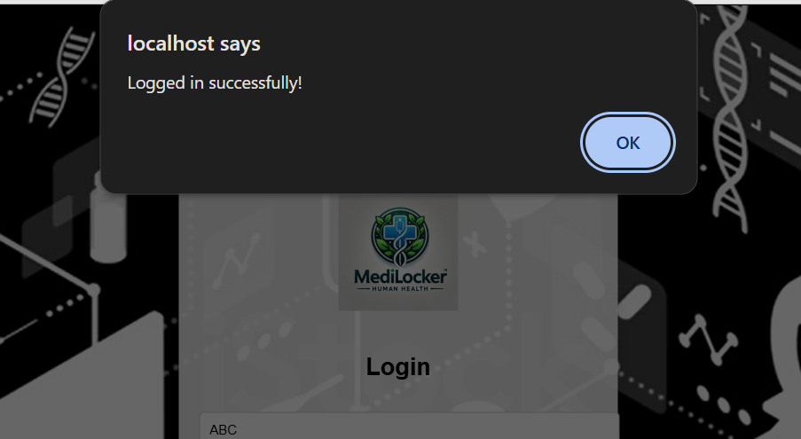

7.5 home page

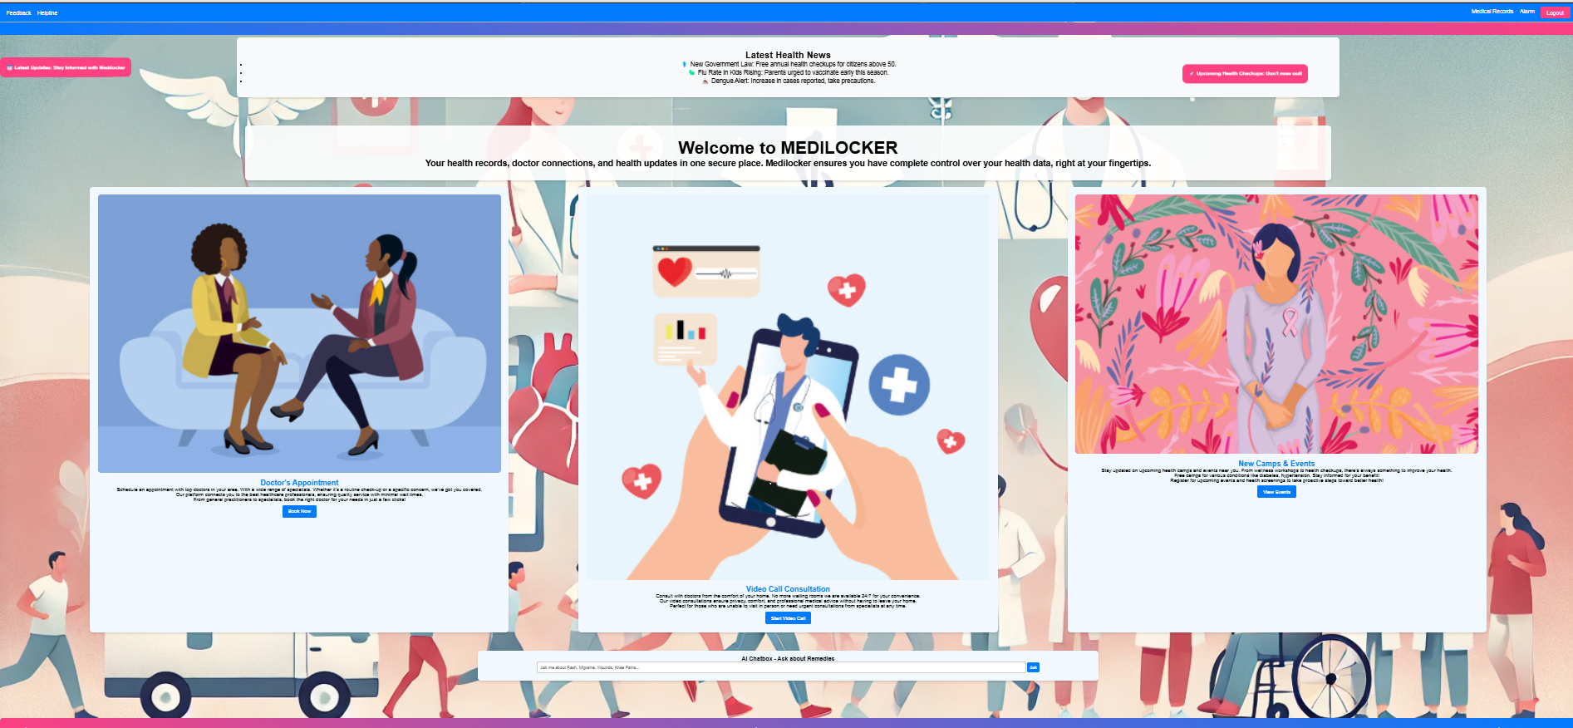

Fig-7.5

7.6 Appointment, Consultation and Events

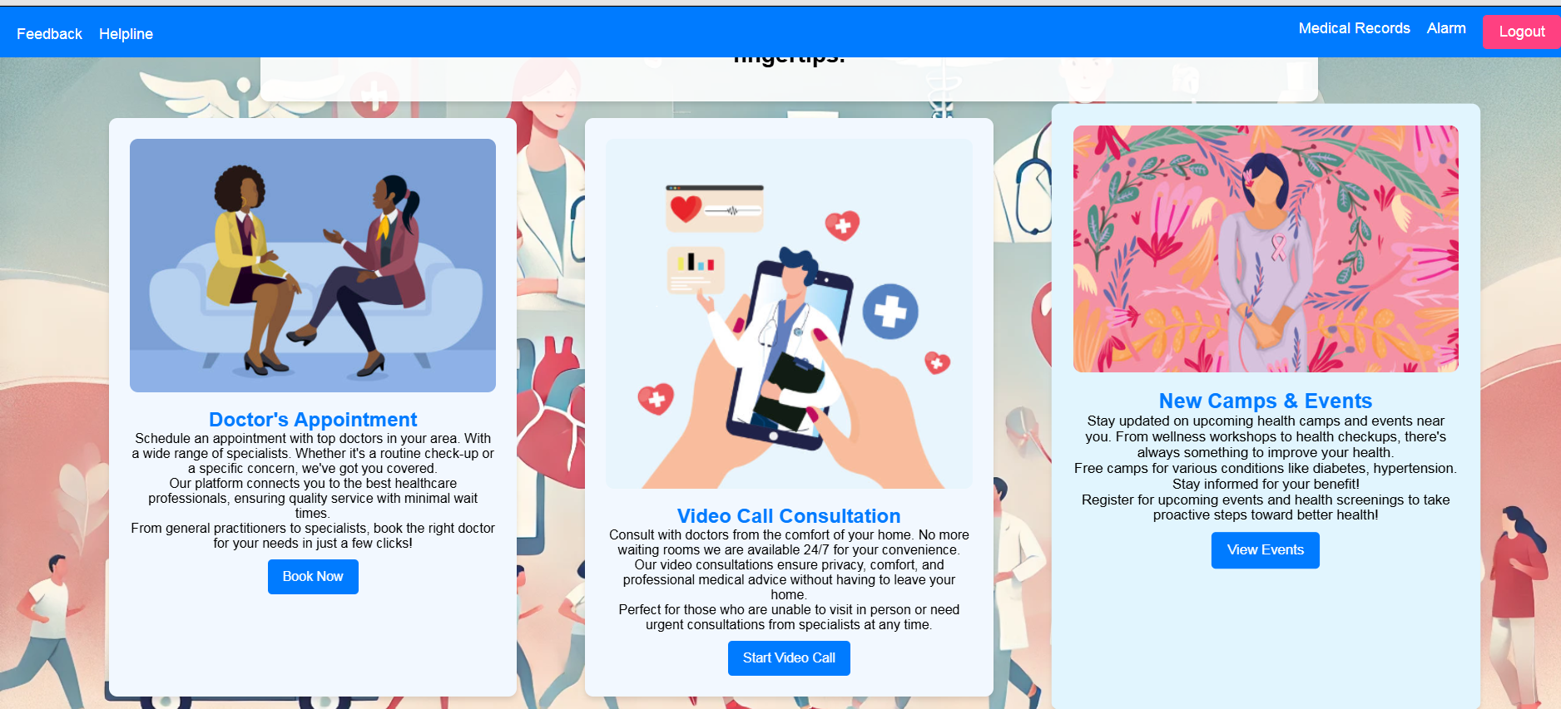

Fig-7.6

7.7 Doctors Appointment

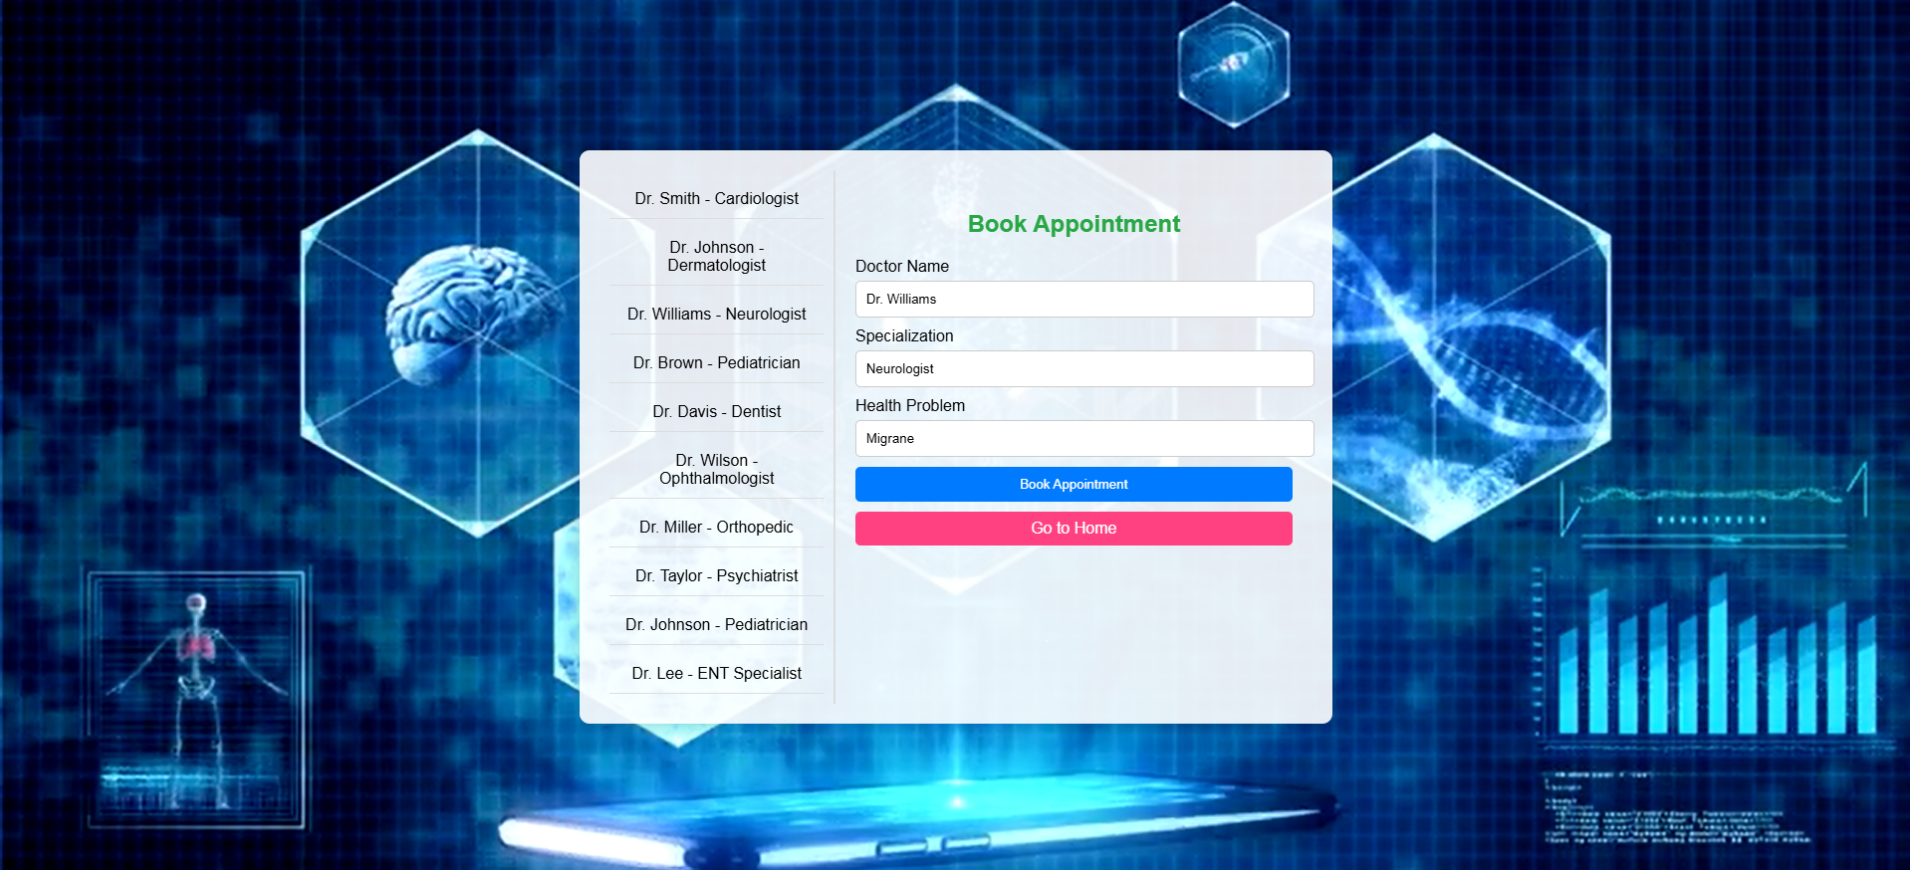

Fig-7.7

7.8 Doctor Appointment Booked Successfully

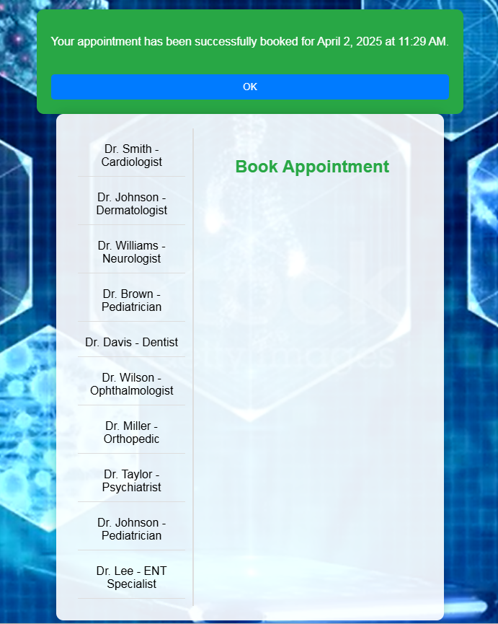

7.8 Video Call Appointment Form

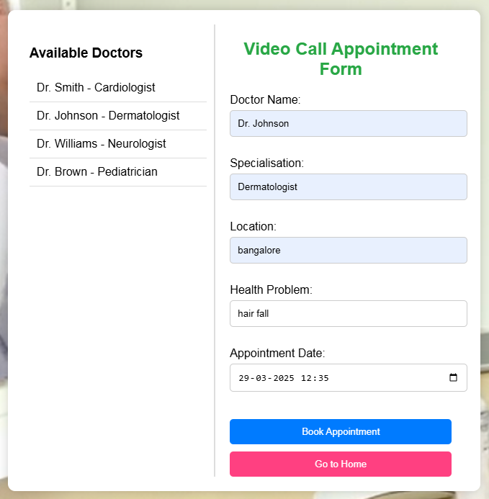

7.9 Video Call Appointment Confirmation

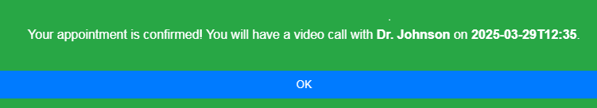

8.0 Camps and Events

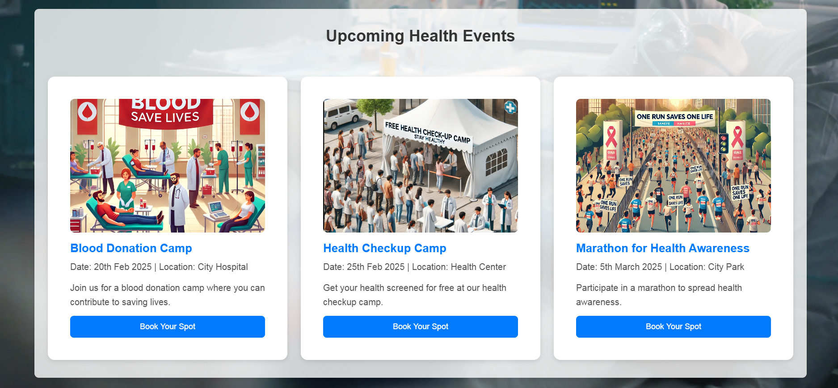

8.1 Blood Donation Camp

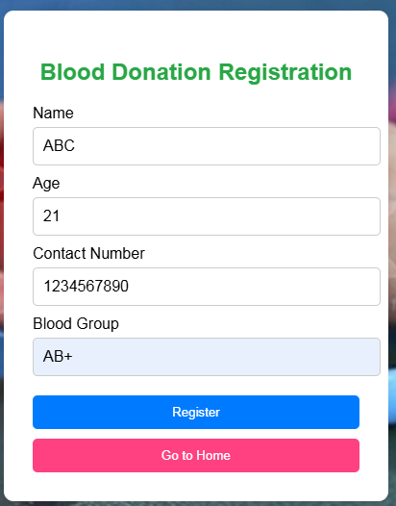

8.2 Registration For Blood Donation Successful

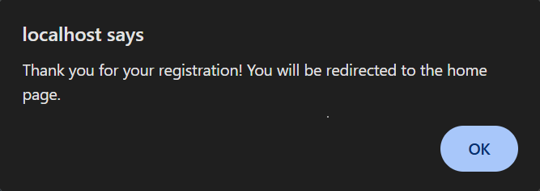

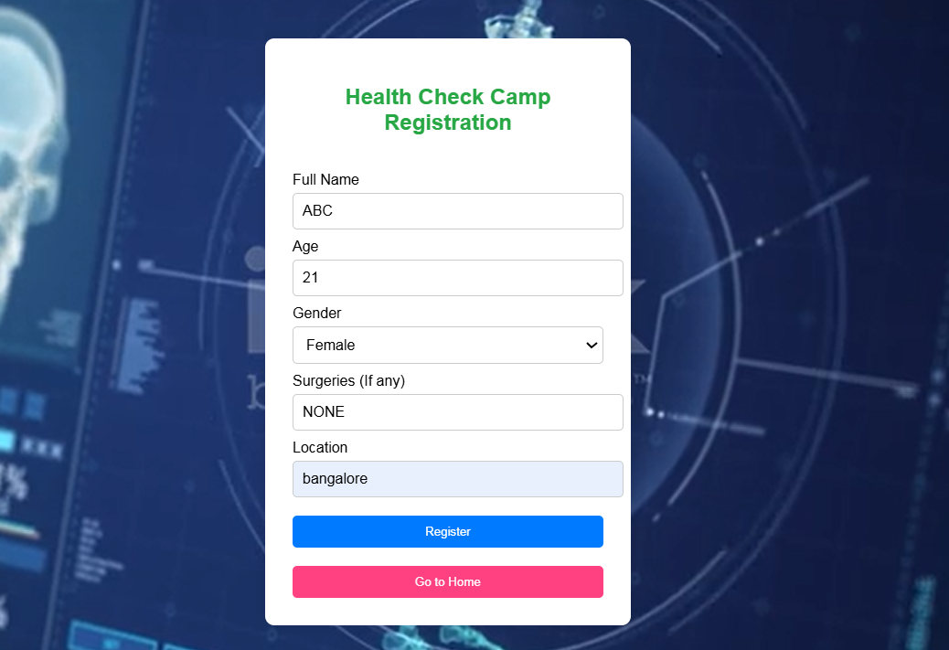 8.3 Health Check Camp Registration

8.4 Health camp registration succesfull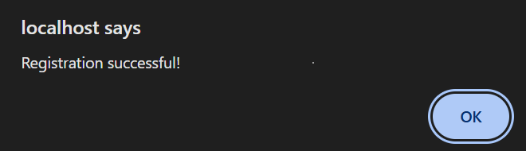

8.5 Marathon Registration

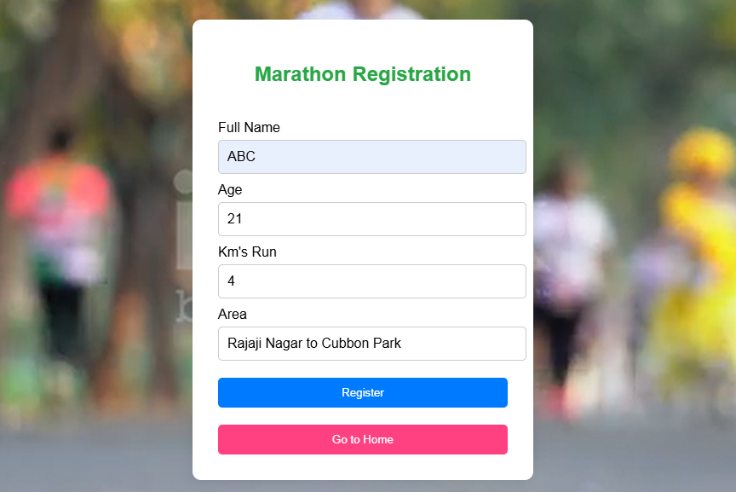

8.6 Registration Successfull

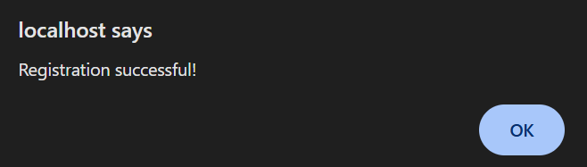

8.7 AI Chatbox and etc

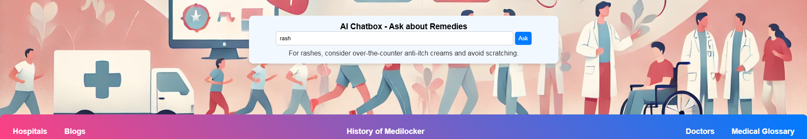

**CHAP TER 8**

**LIMITATIONS**

**Limitations of Medilocker (Minimal Drawbacks, Maximum Benefits)**

Medilocker is designed to provide a **seamless, secure, and efficient** healthcare experience. While it offers a **cutting-edge solution** for managing medical needs, there are a few minor limitations that are continuously addressed to enhance user experience:

1. **Occasional System Updates**  
   To ensure **top-notch performance**, Medilocker undergoes **regular updates**. These are scheduled at **off-peak hours** to minimize disruptions, ensuring the platform remains **fast, secure, and efficient**.
2. **Internet Requirement for Some Features**  
   While most services, such as **appointment booking and medication reminders**, work **offline**, features like **video consultations and real-time AI insights** require an **internet connection** for optimal performance.
3. **Availability of Healthcare Providers**  
   Medilocker collaborates with a **wide network of hospitals, doctors, and pharmacies**, ensuring **maximum coverage**. However, in some remote areas, availability might vary—something we are actively expanding.
4. **AI Chatbot as a Support Tool**  
   The AI-powered chatbot provides **quick health insights and suggestions**, but it is designed as a **complementary tool** rather than a replacement for professional medical advice.

**Why Medilocker Stands Out**

Unlike other platforms, **Medilocker’s limitations are minimal**, and its **constant innovation** ensures an ever-improving experience. With **strong security, reliable service, and AI-driven insights**, Medilocker is revolutionizing healthcare accessibility with almost no drawbacks!

**CHAPTER 9**

**CONCLUSION**

**Conclusion**

The development of **Medilocker** successfully overcomes the challenges faced by traditional healthcare management systems. By integrating an **AI-driven chatbot, video consultations, personalized health tracking, and emergency accessibility**, Medilocker provides users with a **seamless and efficient** healthcare experience.

The platform enhances **healthcare accessibility**, allowing users to **store medical records securely, receive AI-powered insights, book doctor appointments, and access emergency medical services** from the comfort of their homes. Additionally, **strong data security measures** and **user authentication protocols** ensure the highest level of privacy and trust.

Through continuous updates and enhancements, Medilocker aims to **improve user experience, expand healthcare accessibility, and incorporate emerging AI technologies** to provide more personalized and proactive healthcare solutions. Future developments may include **advanced AI-driven diagnostics, mental health support, and wearable device integration** for real-time health monitoring.

In conclusion, this project demonstrates how technology can **revolutionize healthcare services, making them more accessible, efficient, and personalized for users worldwide**.

**CHAPTER 10**

**SCOPE AND ENHANCEMENT**

**Scope:**

**Scope and Future Enhancements of Medilocker**

**Scope of Medilocker:**

Medilocker aims to revolutionize digital healthcare by providing users with a **secure, AI-powered, and easily accessible platform** for managing medical records, booking doctor consultations, and receiving personalized health insights. The platform is designed to serve:

* **Individuals & Families** – Easy access to medical history, prescriptions, and emergency health services.
* **Hospitals & Clinics** – Digital storage of patient records, appointment scheduling, and virtual consultation capabilities.
* **Doctors & Healthcare Professionals** – Simplified patient management, telemedicine services, and AI-driven diagnostics.
* **Pharmacies** – Integration for medicine delivery, prescription tracking, and health reminders.

Medilocker bridges the gap between **patients and healthcare providers**, ensuring smooth communication, **enhanced accessibility**, and **efficient medical care delivery**.

**Future Enhancements of Medilocker:**

1. **AI-Based Symptom Checker & Diagnosis Assistant**
   * Users can input symptoms and receive AI-driven preliminary diagnoses, helping them make informed health decisions.
2. **Blockchain-Based Medical Record Storage**
   * Enhancing data security and enabling **tamper-proof** medical record storage for **secure sharing with doctors**.
3. **Wearable Device Integration**
   * Syncing with **smartwatches and fitness trackers** to monitor vital signs like heart rate, blood pressure, and activity levels.
4. **Mental Health Support & Therapy Sessions**
   * AI-driven **mental health tracking** and online therapy sessions to support mental well-being.
5. **AI-Powered Virtual Health Assistant**
   * A chatbot to answer **basic health queries**, provide **first-aid guidance**, and **suggest lifestyle improvements**.
6. **Global Healthcare Integration**
   * Collaboration with **international healthcare providers** to enable cross-border **medical record access** and **global doctor consultations**.
7. **Voice-Enabled Health Access**
   * Users can access their health data and book appointments using **voice commands**, making healthcare management more accessible.
8. **Community Health Forums & Discussion Panels**
   * A platform for users to **discuss health concerns**, share experiences, and receive advice from experts.
9. **Multi-Language Support for Wider Accessibility**

* Expanding language support to make Medilocker **accessible to people worldwide**, ensuring **inclusivity in healthcare**.

**Conclusion:**

Medilocker is designed to **simplify healthcare management** by integrating **AI, security, and telemedicine services** into one **user-friendly platform**. With **continuous improvements and advanced features**, it will **bridge the gap between technology and healthcare**, ensuring a **seamless and enhanced medical experience** for everyone.

**CHAPTER 11**

**APPENDIX**

**Technologies Used in Medilocker**

**The development of Medilocker, an advanced digital healthcare management system, leverages various technologies to provide a seamless, secure, and efficient user experience. The following technologies were utilized in building Medilocker:**

**PHP (Hypertext Preprocessor)**

**PHP is a server-side scripting language that played a crucial role in Medilocker’s backend development. It enables dynamic content generation, allowing seamless interaction between users and the database. PHP’s core functions in Medilocker include:**

* **User authentication & session management – Secure login, sign-up, and user profile management.**
* **Database interaction – Fetching, storing, and updating user medical records.**
* **Form handling – Processing patient appointments, emergency requests, and video consultation bookings.**

**Since PHP is platform-independent and works with multiple databases, it provided Medilocker with flexibility and reliability in healthcare data processing.**

**XAMPP (Cross-Platform Web Server Solution)**

**XAMPP was used as a local server environment to develop and test Medilocker before deployment. It integrates:**

* **Apache – The web server that processes requests and delivers web content.**
* **MySQL – The relational database system managing patient records, doctor details, and medical appointments.**
* **PHP & Perl – Backend scripting support for Medilocker’s web functionalities.**

**Using XAMPP, Medilocker developers were able to test features locally before making them live, ensuring an error-free experience.**

**Visual Studio Code (VS Code)**

**Visual Studio Code served as the integrated development environment (IDE) for Medilocker. It provided:**

* **Efficient coding with syntax highlighting and debugging tools for PHP, JavaScript, and CSS.**
* **Version control integration with Git, ensuring smooth collaboration and feature tracking.**
* **Extension support for frameworks like Bootstrap, enhancing productivity.**

**VS Code’s lightweight yet powerful interface enabled efficient development and rapid debugging of Medilocker.**

**CSS (Cascading Style Sheets)**

**CSS was used to create a visually appealing and responsive design for Medilocker. It allowed:**

* **Styling of UI components, including buttons, forms, and cards for medical records.**
* **Consistent color schemes and layouts, ensuring a professional medical-themed interface.**
* **Animations and transitions for a smoother user experience.**

**Additionally, Bootstrap was used to enhance responsiveness and optimize Medilocker for mobile devices.**

**JavaScript (JS) – Adding Interactivity**

**JavaScript played a vital role in Medilocker’s frontend interactivity and dynamic behavior. Key functionalities included:**

* **Interactive form validation – Ensuring accurate user inputs for registrations, doctor appointments, and medicine tracking.**
* **Real-time data updates – Auto-refreshing dashboards and appointment schedules without reloading pages.**
* **Event-driven interactions – Enhancing user engagement with AI chatbots and health monitoring tools.**

**Frameworks like jQuery and AJAX were used to streamline JavaScript functionalities, improving response times.**

**Additional Enhancements Used in Medilocker:**

1. **Database Security Features – Using MySQL with encrypted storage for sensitive patient data.**
2. **API Integration – Implementing third-party health APIs for AI-driven diagnostics and medical recommendations.**
3. **Cloud Hosting & Backup – Ensuring secure, real-time access to medical records via cloud-based storage.**
4. **AI Chatbot Integration – Providing users with health suggestions, medicine reminders, and emergency assistance.**

**Conclusion**

**By integrating PHP, XAMPP, VS Code, CSS, and JavaScript, Medilocker ensures a robust, user-friendly, and secure digital healthcare experience. These technologies have allowed the platform to provide seamless medical record management, secure doctor consultations, and AI-powered health insights, making healthcare more accessible and efficient for users.**

**CHAPATER 12**

**BIBILOGRAPHY**

* PHP & MySQL Web Development – by Luke Welling & Laura Thompson
* PHP: A Beginner's Guide – by Vikram Vaswani
* <https://youtu.be/1SnPKhCdlsU?si=78QA8drSK8fMXA>
* <https://openai.com>
* <https://www.geeksforgeeks.org>
* <https://github.com/php>
* PHP In Action: Objects, Design, Agility – Authors: Dagan Reversal, Chris Shiflett, and Marcus Baker
* https://www.tutorialspoint.com/python/index.htm
* Elmasri, Ramez & Navathe, Shamkant B. (2020). Fundamentals of Database Systems
* Learning PHP, MySQL & JavaScript – Robin Nixon
* Modern PHP: New Features and Good Practices – Josh Lockhart
* Web Development with PHP and MySQL – David Sklar